Lecture - 4: SDLC Overview

Software Development Life Cycle (SDLC)

1. Introduction to SDLC
The Software Development Life Cycle (SDLC) is a systematic process used to plan, create, test, deploy, and maintain software applications. It provides a structured framework that ensures software is developed in a controlled, efficient, and high-quality manner.
SDLC defines how software is built, not just how it is coded. It focuses on understanding requirements, managing risks, maintaining quality, and ensuring that the final product meets user expectations.
Without SDLC, software development can become:
- Unstructured
- Error-prone
- Difficult to maintain
- Costly and time-consuming
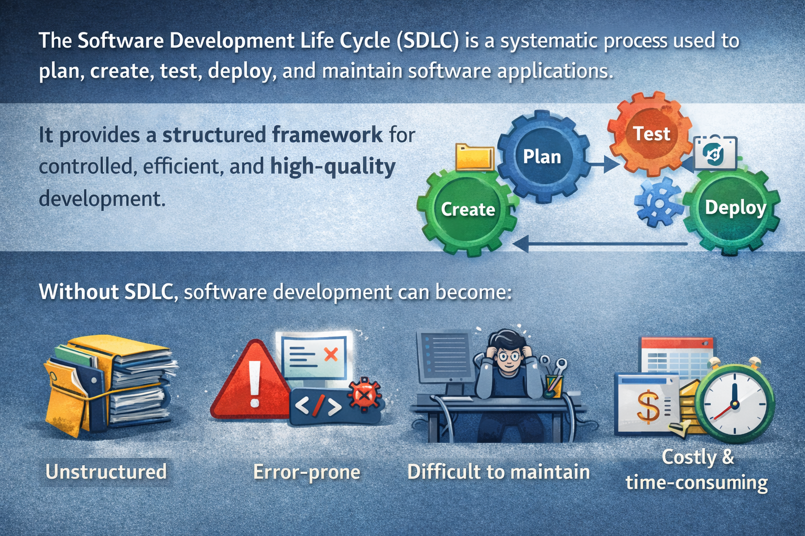

2. Why SDLC Is Important
SDLC is important because it brings discipline and predictability to software development by ensuring every phase is planned, documented, and reviewed, reducing risks and improving overall software quality.

Key Reasons:
- Provides a clear roadmap from idea to delivery
- Helps manage time, cost, and resources
- Reduces project risks and failures
- Improves software quality and reliability
- Makes maintenance and upgrades easier
- Ensures customer requirements are properly addressed
Organizations use SDLC to avoid common problems such as unclear requirements, frequent rework, missed deadlines, and poor software quality.

3. Goals of SDLC
The main goals of SDLC are:
- Deliver high-quality software
- Meet customer requirements
- Complete projects on time and within budget
- Ensure scalability and maintainability
- Reduce development and operational risks
SDLC ensures that software is not just functional, but also secure, reliable, and future-ready.

4. SDLC as a Process Framework
SDLC is not a single method but a framework that defines:
- What activities should be performed
- When they should be performed
- Who is responsible for them
- What deliverables are expected
It divides the software journey into well-defined stages, each with specific objectives and outputs. These stages work together to convert a business idea into a working software product.
The exact number and naming of phases may vary, but the core concept remains the same across all organizations and methodologies.

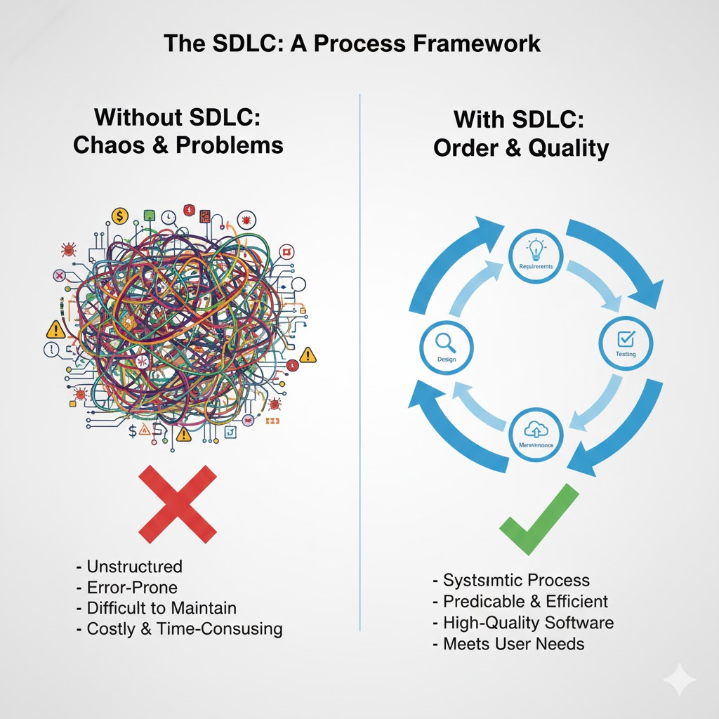

5. SDLC and Software Quality
One of the biggest advantages of SDLC is its focus on quality assurance.
Quality is not checked only at the end; instead, it is built into every step of the process. Early planning, proper design, continuous testing, and regular reviews help detect and fix issues early, reducing costly rework later.
This approach leads to:
- Fewer defects
- Better performance
- Higher customer satisfaction

6. SDLC and Team Collaboration
SDLC promotes clear communication and collaboration among:
- Business analysts
- Developers
- Testers
- Project managers
- Clients and stakeholders
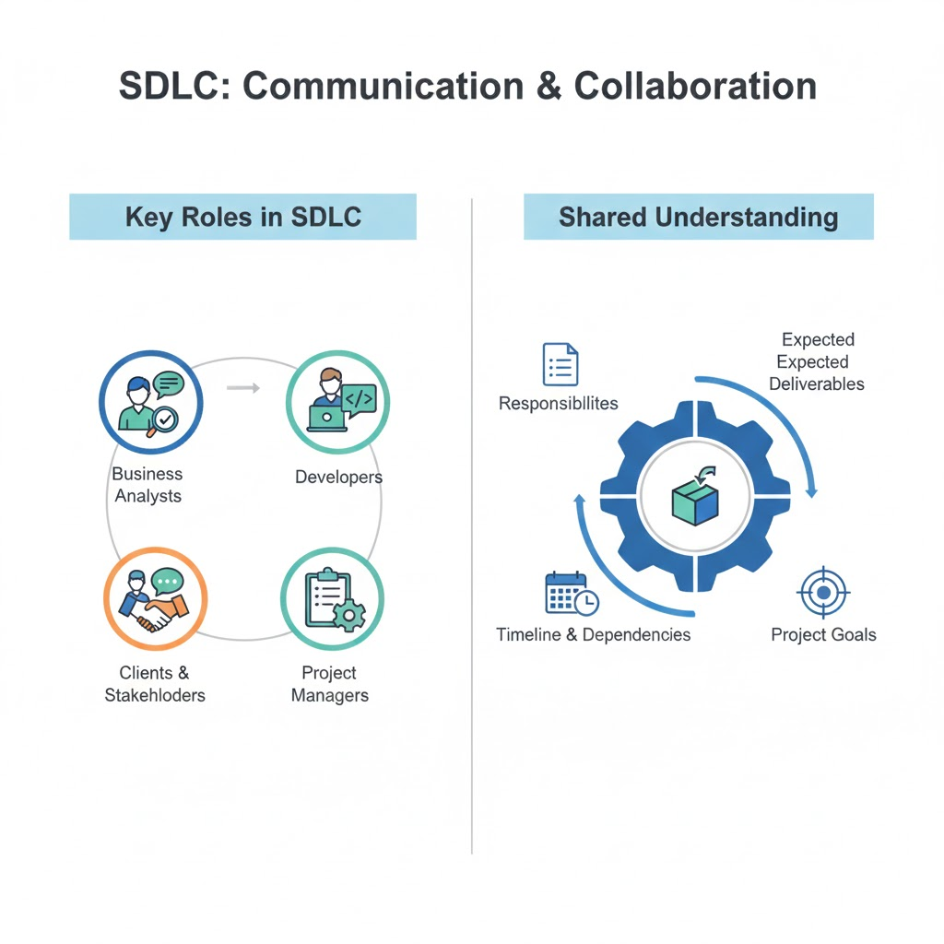
Each role understands:
- Their responsibilities
- Expected deliverables
- Timeline and dependencies
This clarity reduces confusion, overlaps, and conflicts during development.

7. SDLC in Real-World Projects
SDLC is used in:
- Banking and finance systems
- Healthcare applications
- E-commerce platforms
- Government software
- Mobile and web applications
Whether the project is small or large, SDLC helps teams scale development efficiently and manage complexity.
Even modern practices like Agile and DevOps are built on SDLC principles, though they implement them in different ways.

8. SDLC Models (High-Level Introduction)
SDLC can be implemented using different models, such as:
- Waterfall
- Agile
- Spiral
- Iterative
- V-Model
Each model follows the SDLC framework but differs in execution style. The choice of model depends on:
- Project size
- Requirement stability
- Risk level
- Timeline and budget
Detailed discussion of these models will be covered in later lectures.

9. Limitations Without SDLC
Without SDLC:
- Requirements may be misunderstood
- Code quality may suffer
- Testing may be insufficient
- Maintenance becomes difficult
- Projects may fail or exceed budget
Many real-world project failures occur due to poor SDLC implementation, not due to lack of technical skills.

10. Conclusion
The Software Development Life Cycle (SDLC) is a fundamental concept in software engineering. It provides a structured approach to building software that is reliable, maintainable, and aligned with business goals.
Understanding SDLC helps developers think beyond coding and view software development as a complete lifecycle, from idea to deployment and maintenance.
In the next lecture, we will explore SDLC phases in detail, including objectives, activities, and deliverables of each phase.

